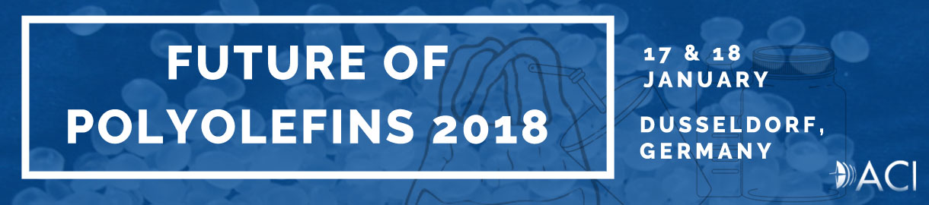
Closing Registration Next Week Friday, 12th January 2018
Following the success of its previous editions, ACI’s 6th annual Future of Polyolefins Summit will be taking place in Dusseldorf, Germany on 17-18 January 2018.
Once again, the conference will look at the supply & demand trends of feedstocks, the global and European polyolefin markets, as well as the main drivers amongst end-products. Building up on last year’s feedback, the event will also take an in-depth look into trends & innovations, new technologies developments and predictions on the long to very long term. Over the two days, the participants will discuss topics such as lightweighting, sustainability & circular economy for polyolefins, as well as bio-based PE & PP, through case studies and interactive discussions led by industry experts.
This new edition will bring together senior executive from petrochemical companies, plastic converter, technology providers, chemical intermediate suppliers, researchers, as well as other influential stakeholders from the value chain.
Agenda link: http://www.wplgroup.com/aci/wp-content/uploads/sites/2/2017/06/CFPe6-Agenda_MKT.pdf
Confirmed Companies Include: TOTAL Petrochemicals & Refining SA, Sika Automotive GmbH, Stora Enso, SABIC, Ford, Renault, ABU DHABI POLYMERS CO. LTD (BOROUGE) L.L.C, Brückner Maschinenbau GmbH & Co. KG, Omya International AG, INEOS Olefins & Polymers, Borealis Group, KIVO Plastic Verpakkingen., Gunvor Raffinerie Ingolstadt GmbH, Dover Chemicals, Braskem Netherlands B.V., COREPLA, DPI - The Polymer Research Platform, MOL, Plastics Europe, Borealis, McKinsey, Townsend Solutions, DuPont, Petrochemicals Europe, QCPolymers, Ellen MacArthur Foundation, German Chemical Industry Association, NCT Holland B.V., Grace GmbH, Wood Mackenzie, Valeron Strength Films, Fluid-Bag Ltd, Toho Titanium Co., Ltd., NMC Sa, Siak Technology, Synthosgroup and many others...
Join us in Dusseldorf to exchange your point of view with your peers and engage in excellent networking opportunities.
Venue - Steigenberger Parkhotel Dusseldorf (www.duesseldorf.steigenberger.de )
Registration link: http://www.wplgroup.com/aci/event/polyolefins-conference/
For more information and subscriber’s discounted registration, please contact:
Mohammad Ahsan
+44 (0) 203 141 0606
mahsan@acieu.net

